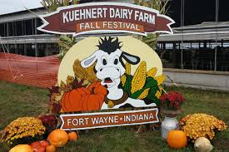
October Recap:
Hi NEIAND members! It appears that winter has arrived early this year. Hope you all are staying warm! Thank you to all the members who were able to come out and volunteer with us at the Kuehnert Dairy Farm Festival! It was such a beautiful and busy day! Our volunteers stayed busy parking cars, serving food, driving the corn maze tractor, and supervising the jump pad. To say we had fun is an understatement. If you weren’t able to volunteer this year, please keep it in mind for years to come. This is a great opportunity to get outside, enjoy the fresh air, help a fellow NEIAND member’s family, and raise money our organization! This year we received a $700 donation. In order to be able to continue participating in this fundraiser we need your support. Please consider volunteering for next year!

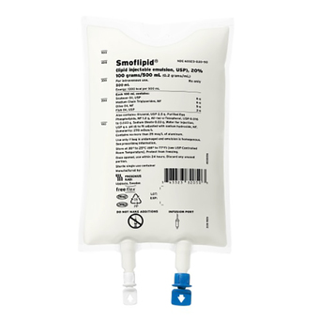
December Event:
When: Dec 4 at 5pm - 7pm
Who: A Medical Science Liaison from Fresenius Kabi will be discussing their company and two of their products, Omegaven and Smoflipid. 1 Hour CEU.
Where: USF North Campus Building Room 211. RSPV to bmoellering@sf.edu
Please note unfortunately Fresenius will no longer be able to provide a dinner for the event. Instead we will be doing a Christmas (or favorite) cookie exchange. Please bring 1-2 dozen of your favorite homemade (or store bought – no judgement ) cookies and recipes to share! We thought this would be a fun way to help everyone get into the Christmas season.

Holiday Memories:
I can’t believe the holidays are fast approaching. Thanksgiving and Christmas are just around the corner! Holidays often are a time for spending time with families or partaking in annual traditions. Are there certain traditions you look forward to most? Or do you have favorite holiday memories that you share with family and friends. Check out what some of our Board members remember most about their holidays:

Bev Moellering: The first year we were married the first gift my husband opened at his parents’ house was a pair of socks that were made up of one red and one green sock. The tradition in their family was once you were married the men would receive the red/green pair of socks to only be worn on Christmas Eve and Christmas Day. Fast forward being married for 21 years my husband still has those same pair of socks and wears them every Christmas.

Amanda Langan: My favorite memory from the holidays is the prep the night before. My mom always made her stuffing (or dressing if that's your thing) from scratch. After we ate dinner and cleaned up the dishes my siblings and I would all sit at the table with a huge metal bowl in the middle and help tear up loafs of bread for the stuffing. I can still hear my mom's voice says "those pieces are too big/too small". It felt like it took hours to tear up all the bread but it was the most relaxing time before all of the hustle of the holiday meal. Now I do this at my house every year on the night before Thanksgiving or Christmas. My boyfriend has now been educated on how to "properly" tear up bread for stuffing.

Jenny Gotsch: Every year on Christmas morning my family would get together at my Grandparent’s house to eat brunch consisting of egg casserole, homemade pecan rolls, and fruit salad. Over the years, even after the passing of my grandparents and cousins moving away, we all still make our Christmas brunch every year as we had growing up. To me Christmas morning would not be the same without it!

January Event:
When: January 14th at 5:30 pm
Where: Dupont Hope House
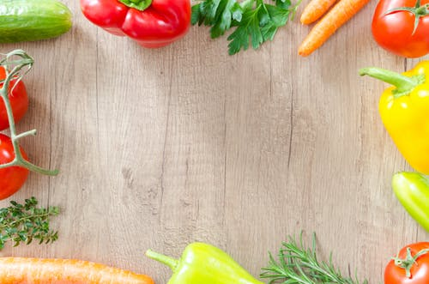
What: This year we will be volunteering at the Dupont Hospital Hope House by providing a dinner for the families staying there. They recommend planning to serve 10-12 people. I am also in contact with their coordinator to see if they could us any other needs for donations besides foods that we can bring. Please contact us if you would like to provide food, supplies, or monetary donations to help supply this event. Pleases stay tuned for updates.
Save the Date!
Thursday, February 27th 2020
Indiana Academy of Nutrition and Dietetics
(www.eatrightin.org)
Day at the Statehouse

