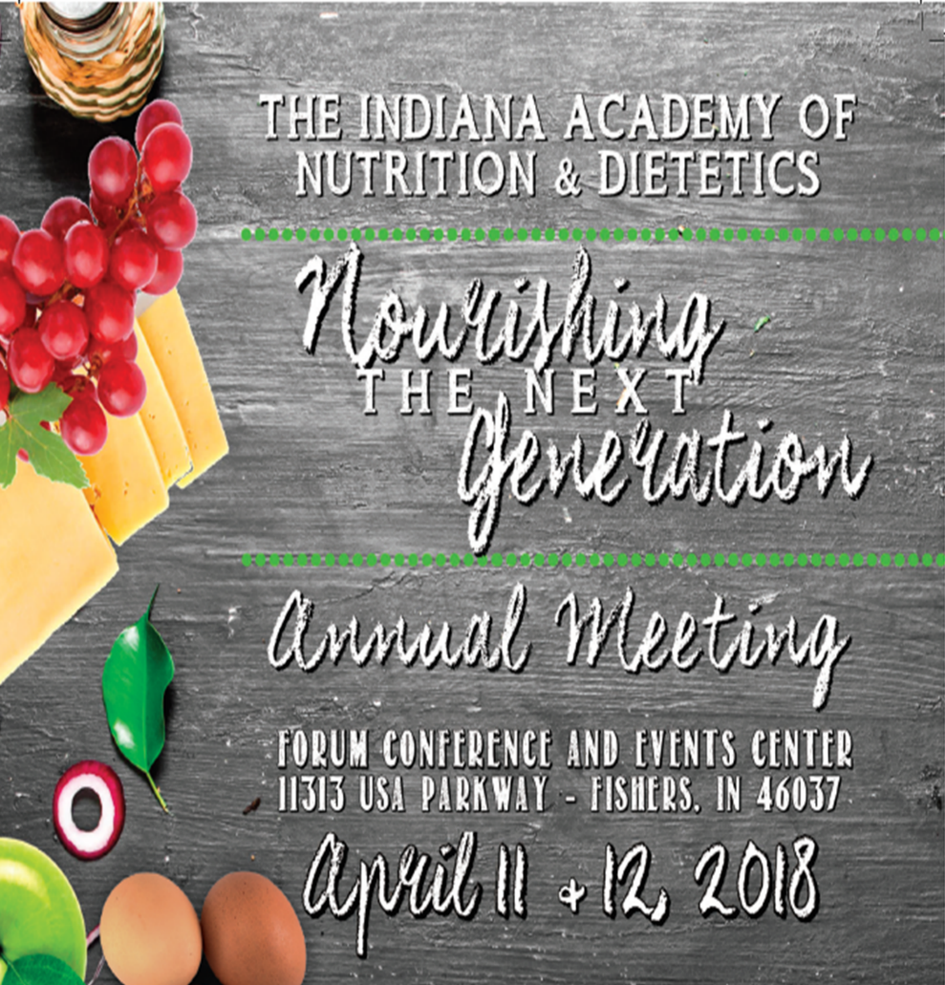

CPE STATUS
Level 3: Education Sessions Level 2: Poster Session Level 1: Exhibits
Thank you for joining us for the 2018 IAND Annual Meeting. This document serves as your Continuing Professional Education Certificate of Attendance.
- KEYNOTE | 1 CPE
- POLITICAL ACTION BREAK | 0.5 CPE
- SESSION 1A OR 2B | 1 CPE
- SESSION 2| 1 CPE
- SESSION 3| 1 CPE
- SESSION 4A OR 4B | 1 CPE
- INDHCC BREAK | 0.5 CPE
- SESSION 5 | 1 CPE
- SESSION 6| 1 CPE
- FOOD EVOLUTION EVENT | 3 CPE’S
Day 2
- KEYNOTE | 1 CPE
- SESSION 1 OR STUDENT SESSION| 1 CPE
- SESSION 2| 1.5 CPE’S
- EXHIBITS | 1 CPE
- ACADEMIC POSTER SESSION | 1 CPE
- SESSION 3 | 1 CPE

SUGGESTED PERFORMANCE INDICATORS (PI)
1.1.8 Adheres to the Standards of Professional Performance for RDN’s.
2.2.4 Collaborates with others when the required skill is beyond his/her competence.
4.1.2 Interprets and integrates evidence-based research and literature in decision making.
8.1.2 Applies knowledge of food and nutrition as well as the biological, physical and social sciences in practice.
11.2.5 Reviews and evaluates science and evidence-based literature, to validate claims.
12.1.1 Promotes nutrition programs and resources to address issues of food security, nutritional health and disease.
12.1.3 Collaborates with community partners and stakeholders in promoting nutritional health and disease
prevention.

SUGGESTED LEARNING NEEDS CODES (LNC)
1050: Ethics
2040: Science of food and nutrition

5000: Medical Nutrition Therapy
7170: Reimbursement, coverage
8110: School foodservice

Mark McInernet, DHSc, RD, CD Sarah Kuehnert, RDN, CD
President-Elect, General Chair CPI, Program Chair

DAY ONE: Wednesday, April 11, 2018
8:10-9:00am Keynote Address: Academy Update 2018
Speaker: Donna Martin, EdS, RDN, LD, SNS, FAND
Program Objectives:
1. To highlight current activities and recent development at the AND and FAND. 2. Spotlight new and continuing benefits of AND membership.
3. Address the Academy’s activities and successes are the areas of public policy and advocacy, media outreach and scientific research.

9:00-9:30am Political Action Update: Farm Bill Nutrition Programs
Speaker: Brandon Herget, Senator Donnelly’s Deputy State Director
Program Objectives:
1. Identify current State and Federal nutrition legislative initiatives.
2. Discuss action alerts, TROA and the Farm Bill.

9:30-10:30am Session 1A: Code of Ethics
Speakers: Hanna Kelley, RD, CD; and Kate Capen, RDN, LD, CD
Program Objectives:
1. Understand the difference between ethics and morals.
2. Verbalize the AND Code of Ethics and know where to find resources.
3. Identify common situations across the full spectrum of dietetics profession that have ethical implications

Session 1B: Nutrition for Special Populations
Speaker: Amy Carter, MA, RD, CD, CDE
Program Objectives:
1. Identify barriers to nutrition compliance in defined special populations.
2. Identify food/resources to assist in nutrition compliance.
3. Discuss strategies for assisting special populations with chronic disease.

10:30-11:30am Session 2: Fitting Nutrition into you Genes: Working Molecular Biology into Your Practice
Speaker: Martha Belury, PhD, RD
Program Objectives:
1. Discuss the overview of research involving genetics, diet and nutrition.
2. Review terminology that is useful in clinical applications of genetics and dietary fat quality in relationship to health and disease of adults.
3. Identify chronic health conditions whereby dietary fat quality works with genes to influence health outcomes.
4. Learn how to integrate nutritional and metabolic status with genetic predisposition for personalized dietetic practice.

12:30-1:30pm Session 3: Omega 3’s Athletes and Brain Health
Speaker: Tavis Piattoly, MS, RD, LDN
Program Objectives:
1. Understanding the versatility in Omega 3’s and their benefits and research on brain health, inflammation, body composition and performance.
2. What does the research say regarding Omega 3 dosing guidelines for general health vs athletic performance?
3. Understanding the different forms of Omega 3’s for optimal absorption and bioavailability.

1:30-2:30pm Session 4A: Is it OK to Eat Farmed Seafood?
Speaker: Steve Hart
Program Objectives:
1. Debunk common aquaculture myths.
2. Overview of current aquaculture practices.
3. How to make informed seafood purchases.

Session 4B: Creating a Collaborative Approach between Therapists and
Dietitians
Speakers: Lolly Wool, M.Ed., LPC, NCC and Chelsea Martin, RD, LD, CRDRD
Program Objectives:
1. Provide clinicians with a variety of tools that will help create a cohesive team between therapist and dietitian in order to better meet the client’s needs.
2. Offer a philosophy of treatment that incorporates a team approach.
3. Propose tools to deal with splitting, projection and other maladaptive attachment strategies.

2:30-3:00pm IN DHCC Update
Speaker: Hanna Kelley, RD, CD
Program Objectives:
1. Identify tools and resources available to assist Registered Dietitians working in Healthcare community settings.
2. Implement strategies to facilitate the process of delegated orders for therapeutic diets in Long Term Care facilities.
3. Recognize opportunities for career enhancement.

3:00pm-3:45pm Session 5: More than Keeping You Regular: How Fiber-Microbiome
Interactions Shape Health
Speaker: Dr. Stephen Lindemann, Ph.D.
Program Objectives:
1. Review cutting-edge research linking fiber consumption to health via the gut microbiome.
2. Explore linkages between different fiber structures and gut microbiome function.
3. Make a case for more fiber-specific attention in regulation and dietetic practice.

3:45-4:30pm Session 6: Stop Telling Me What To Do. Evoking Your Patient’s Motivation.
Speaker: Julie Pike, RD, CDE
Program Objectives:
1. Define motivational interviewing.
2. Identify the four processes of motivational interviewing.
3. List the core interviewing skills used in motivational interviewing.

5:00-8:00pm Evening Event: Screening of Food Evolution:
Location: Wellington Fishers Conference Center
Speaker: Trace Sheehan
Program Objectives:
1. Discover the effects of science and technology on today’s agriculture systems and prepare Dietitians to discuss this information.
2. Recognize global implications of food production decisions and their impact on local communities and economies.
3. Identify and discuss implications for Dietitians and how they affect recommendations regarding GM foods.

DAY TWO: Thursday, April 12, 2018
8:05-9:00am Keynote Address: Humor Helps Us Thrive on Change
Speaker: John Wagner
Program Objectives:
1. Learn about your comfort zone, and the two powerful behaviors you can use to breakthrough it.
2. Learn to lighten up and use positive humor to manage the stress associated with change.
3. Learn how to receive happiness through the act of giving.

9:00-10:00am Session 1: Reimbursement: New Game, New Rules
Speaker: Marsha Schofield, MS, RD, LD, FAND
Program Objectives:
1. Describe current trends in healthcare delivery and payment models impacting RDN’s and NDTR’s and recognize opportunities to provide nutrition services within these models.
2. Develop business strategies for successful business practice and payment. 3. Use Academy resources to support advocacy and marketing efforts related to nutrition services inclusion and coverage.

9:00-10:00am Student Session: Power of Choice
Speaker: John Wagner
Program Objectives:
1. Learn the basics of Choice Theory (developed by William Glasser M.D.)
2. Learn to apply power of choice to improve your results.
3. Learn to apply power of choice to improve your interactions with others.

10:15-11:45am Session 2: Consumer Perceptions of Genetically Modified Foods Panel
Speakers: Dr. William Hallman, PhD, Trace Sheehan, Joe Kelsay, and Roxi Beck
Program Objectives:
1. Identify areas of controversy regarding public perceptions of genetically modified (GM) foods and other food technologies.
2. Recognize the complex issue of consumer choice and how it affects nutrition communication with the public.
3. Identify and discuss implications for Dietitians and how they affect recommendations to consumers.

11:45am-1:15pm Lunch, IAND Business Meeting and Awards Program

1:15-3:15pm EXPO and Poster Sessions

3:15-4:30pm Session 3: Selling Good Nutrition: Marketing Your Child Nutrition Program
Speaker: Barbara Minger, MS, RD
Program Objectives:
1. To promote methods of marketing school nutrition programming in order to increase participation.
2. To review nutrition regulations required by schools.
3. To review creative methods of encouraging good nutrition throughout the day, including education that students will use for a lifetime.

