Outstanding Dietetic Student Award  Indiana Academy of Nutrition and Dietetics  2023-2024 Application | 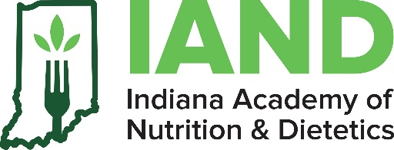

Please provide the following information.
Academy Membership Number
First Name
Middle Initial
Last Name

Address
Street
City
State
Zip
Email Address

District <if applicable>
District

STUDENT'S CURRENT EDUCATIONAL PROGRAM

Institution Name
City/State

Dietetics Education Program Type <circle one>
CP | DI | DPD | DT

ACTIVITIES AND HONORS
Briefly list achievements including: honors (academic and other), student dietetic association activities, community service activities, etc.

Activities, Honors, or Organizations: | Dates

VOLUNTEER EXPERIENCE
Briefly list volunteer experience focusing on that related to dietetics and nutrition specifically:

Organization and Position: | Dates

ADDITIONAL INFORMATION
- All applications must be returned by 02/2/2024
- Students must supply their membership number; membership identification numbers will not be provided to third parties (i.e., educators).
- Please attach a photo of the student you are nominating, one letter of recommendation, one personal statement, and the student’s resume.
- Complete this form and return to stasik.morgan@gmail.com

MEMBER CERTIFICATION
I have reviewed the criteria for this award and attest that I have not received this award from this or any other affiliate previously as well as meet all other criteria for the award I am applying for
Signature Date

